N-K-1 POEXPORT

POEport allow transferring purchase orders for board vendors directly to the corrugator complete with sheet width, length, adders, setup charges, score types and score allowances.

Character value dictates the method of download. Options are ALLIANCE, GP and HRMS, VENDOR, CORRTRIM, CORSUPLY, COR-U-KRAFTII and NONE. If the value is set to VENDOR, then each board vendor must have the purchasing export method defined in the vendor file field called POEXport. Also, the file transfer may need to be set up by ASI, whereas the folder to download the data is dictated by the N-K-1 description field for each vendor. For example, the N-K-1 Alliance must be defined for the down load option.

Integer Value = 0 means that the file will be sent to the vendor.

Integer value to 1 and the file will not be sent. By setting the value to 1, the program will disable the toggle box / question "Transfer to Corrugator".
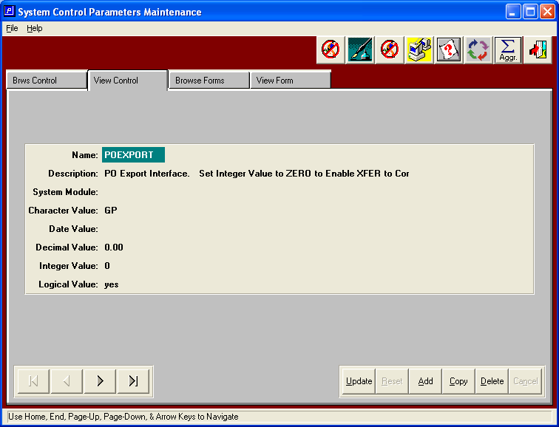

N-K-1 GP or N-K-1 CorrTrim or N-K-1 Alliance or N-K-1 Kiwi etc.

This parameter sets the path for the file export (the drive letter should be your server drive letter where rcode is located)

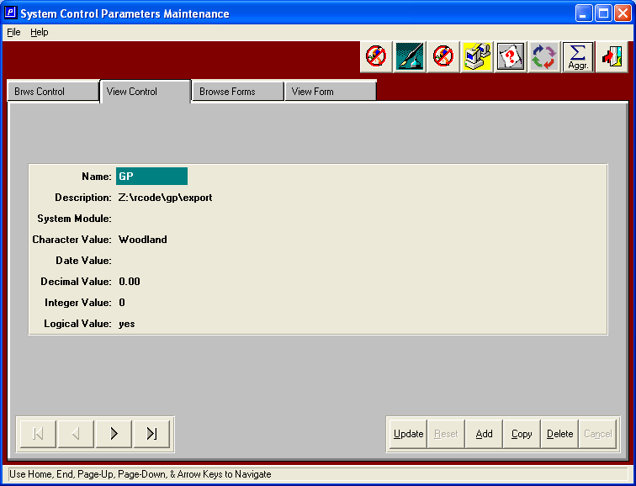

Electronic transfer to purchase orders to your board vendor is available via the toggle box
Called “Transfer to Corrugator?” Your board supplier will gladly pay for this option as this eliminates the data entry step at their plant. This also places your order into their scheduling system that much sooner, so that your orders will get delivered sooner.

